

"Beyond the stars, we build not just a colony, but a new chapter for humanity—where the seeds of Earth bloom in the gardens of distant worlds."



1). Introduction:

Why is GAIA’S REACH the only name for the project?

OUR PROJECT IS NAMED GAIA’S REACH BECAUSE GAIA IS THE GODDESS OF EARTH AND MOTHER OF ALL LIFE.

IN OUR PROJECT ON SPACE COLONISATION, WE LOOK FORWARD TO EXTENDING THsESE GODDESSES REACH.

OUR MERITOUS TEAM CONSISTS OF THE FOLLOWING PEOPLE:

1) ONKAR 6) RUSHIL

2) AYUSH 7) DARSH

3) NABHANYU 8) PARTH

4) NABHYA 9) HRIDHAY

5) RUDRA

GAIA’S REACH ALSO SYMBOLIZES EXTENDING THE LIVING HABITAT AND FAVOURABLE LIVING IN SPACE COLONY BEYOND THE EARTH'S ATMOSPHERE.

THERE WILL BE SOME DAY WHEN OUR EARTH WILL NOT BE HABITABLE SO WE NEED TO GO OUTSIDE THE EARTH TO LIVE WE SHOULD PREPARE NOW SO WE SHOULD GET READY BEFORE IT HAPPENS.

2). DESIGN OF THE PROJECT

The design of our space model is given below

1. Artificial Gravity  
   Ring-like structures, presumably employ centrifugal force to produce an artificial gravity-an essential requirement to have human existence beyond a reasonable period in space. Rotation of these rings develops artificial gravity so that people living there could have a state of simulation for an Earth-like environment, which aids in preventing physical health problems with long-term exposure to microgravity, including bone loss and muscle wasting.

2. Maximizing Space Usage  
From the appearance of the colony, it has levels inside its round structures, which could maximise habitation space, farming-plotted areas possibly hydroponic systems, and other necessary functions. This multi-layer design makes the station more habitable without increasing its footprint, which is efficient for living in space.

3. Solar Power  
The solar panels are so large and mounted out of the structure, implying that the colony is powered by the sun. This would be ideal for space colonies since it could readily harness sun energy to supplement the electricity supply of the colonists. This would work well for life support, farming, and technological infrastructure.

4. Radiation Protection  
These rings could have quite a thick, closed structure to potentially shield against cosmic radiation. Cosmic radiation is harmful, and the overall levels of it are very high, it impacts living space due to its effects in space. It would pose a big risk to human health, so a well-insulated structure would help lessen these risks and protect the colony's inhabitants.

  
5. Modular Expansion  
The colony's design can be modular, with a central core and additional rings or sections that can be added to the colony as its size expands.  
This is important because a space colony can grow to meet its size and needs as the population and technology change with time.

6. Transport and docking systems  
This is supported also by several surrounding smaller spacecraft and potential docking areas; it appears that this colony serves as some kind of transportation hub. Such a colony would be used as an interstellar or interplanetary waypoint, with facilities for other ships to dock, facilitating trade, resupply, and passenger transport.

2.1) location and the Lagrange point of the colony:

Why Lagrange Point 4 (L4)

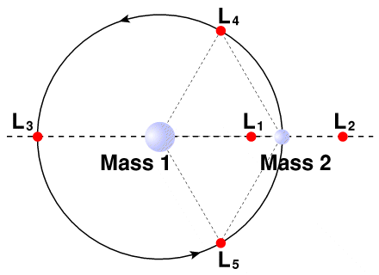  
Gravitational Equilibrium Stability:  
  
L4 allows an equilibrium to be formed between the gravitational forces of Earth and the Sun, which would allow a colony in space to sit in nearly a fixed position with minimal energy required to maintain station-keeping.  
Continual Solar Irradiation:  
  
The colony would essentially experience permanent daylight, essential for solar power generation, for both life support and technologies such as hydroponics.  
Research and Development Opportunities:  
  
L4 provides excellent observing conditions for astronomy and solar studies that enable the study of solar activity, free from atmospheric interference.  
Accessibility:  
  
Since L4 is farther than LEO, it is relatively accessible to resupply missions, making logistics, trade, and communication with Earth easier.  
Shielding from Earth:  
  
The distance from Earth protects from the impact of space debris and atmospheric disturbances, increasing further the safety and sustainability of the colony.

  
Why Low Earth Orbit (LEO)

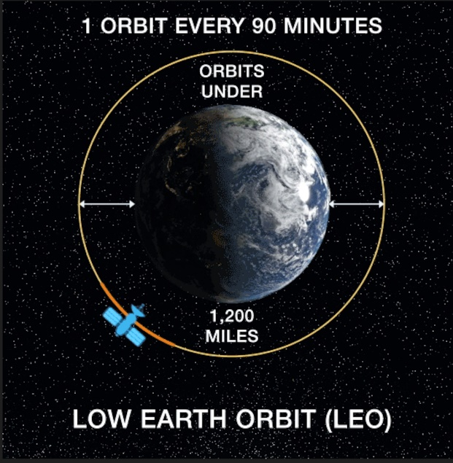  
Proximity to Earth:   
  
LEO is much nearer to Earth (160 to 2,000 kilometres), thus quicker travel times for resupply missions and human transport.  
Faster Communication:  
  
The short distance has reduced latency in communications, which is crucial for operational activities and emergencies.  
Infrastructure Development:  
  
Any established mission, such as the ISS, can be utilized as a starting point and leverage existing infrastructure to make setup and collaboration more accessible.  
Research and Development:  
  
The microgravity environment at LEO is ideal for conducting scientific research and testing technology, which will bear benefits for future colony developments.  
Expandibility Potential:  
  
LEO is in the form of a modular system, hence easily expanding and upgrading with new technologies coming in, thus ensuring the adaptation of settlement.

2.2) Thrusters and Docking Ports:

International Docking System Standard (IDSS)

Compatibility:  
  
The IDSS is as wide as possible in its compatibility for various spacecraft and can dock both on government and commercial spacecraft, thereby allowing resupply from multiple sources through a single logistical operation.  
Safety and Security:

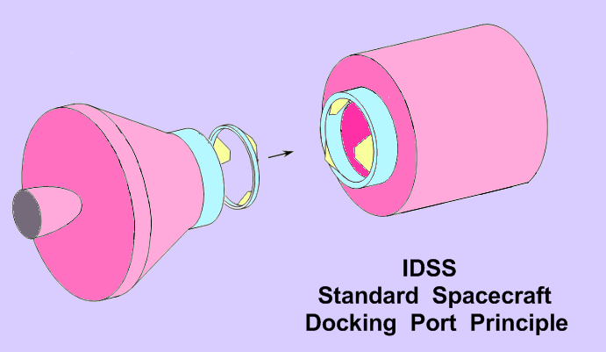

  
  
This would make the IDSS architecture very well-suited for a safe vessel-to-vessel connection, which will be of critical importance in transferring resources and personnel on missions as the ion thrusters burn off at low thrusts that will require docking with even greater accuracy.  
Standardization  
  
As an international standard, IDSS ensures standardization in the training and operational procedures for crew members and mission controllers. Such standardization between these space agencies and private sectors promotes collaboration, which is beneficial in operational operations.  
Future-proofing  
  
The IDSS is flexible enough to keep pace with evolving designs and technologies for future spacecraft, thus it may expand with the progress of space travel. This can be a ticket to long-term sustainability and growth.

Ion Thrusters:

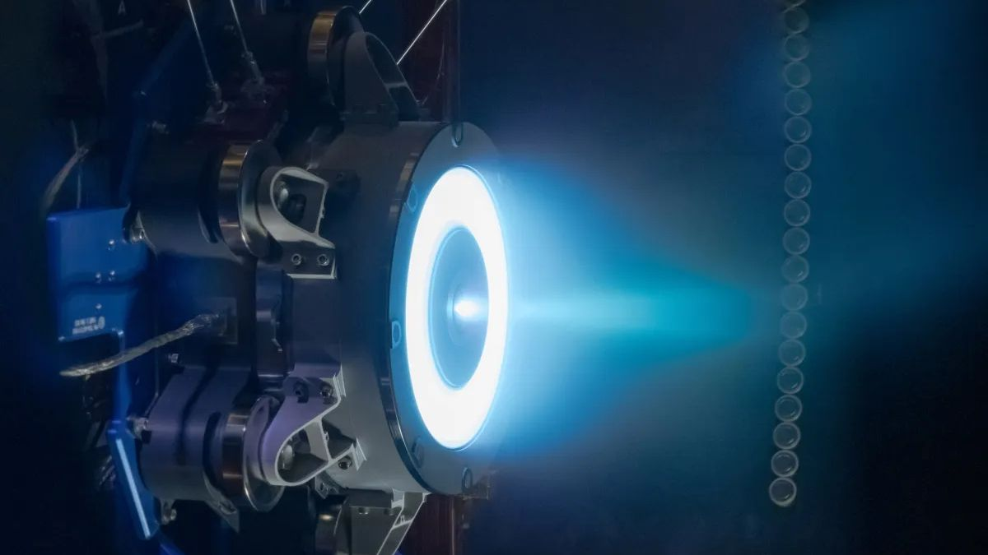

An ion thruster produces a much higher specific impulse than a conventional chemical rocket. That is to say, for a given mass of fuel, it has greater propulsion, which would be required for longer-duration missions characteristic of space colonies.  
  
Long Service Life: They can run for long periods, thus providing smooth acceleration, and with the possibility of slight corrections in the colony's position. That is very useful for keeping L4 stable.  
  
Gas Mileage: This will conserve fuel for any deep-space mission where resources are scarce. This is another reason that supports the permanence of your space colony.

Constant Working: The ion thrusters can last for thousands of hours. Thus, steady thrusts would be provided that would sustain station keeping and manoeuvring in space. In such a way, the colony shall maintain a specific position while consuming very little energy.

3) Life support:

3.1) **Oxygen Generation and Carbon Dioxide Removal**

In this section, I will discuss the processes of oxygen generation and carbon dioxide (CO₂) removal in the space colony's life support system. Maintaining a balanced atmosphere is essential for the survival of inhabitants, and several methods will be employed:

**1. Photosynthesis in Plants**:

* Plants will generate oxygen through photosynthesis by absorbing CO₂ and using sunlight to convert it into glucose and oxygen (O2).
* The oxygen produced provides a continuous supply of breathable air while recycling the CO₂ released by inhabitants.

**2. Chemical Oxygen Generation from CO₂**:

* Chemical methods will convert CO₂ back into oxygen, enhancing the life support system's efficiency. One method is using solid oxide electrolysis cells (SOEC) to perform high-temperature electrolysis, allowing the conversion of CO₂ into oxygen and carbon monoxide.​

By integrating these methods—oxygen generation through plants and chemical conversion of CO₂—we can establish a sustainable life support system that ensures a balanced atmosphere for the inhabitants of the space colony.

3.2) Water Recycling and Urea Stabilization in a Space Settlement

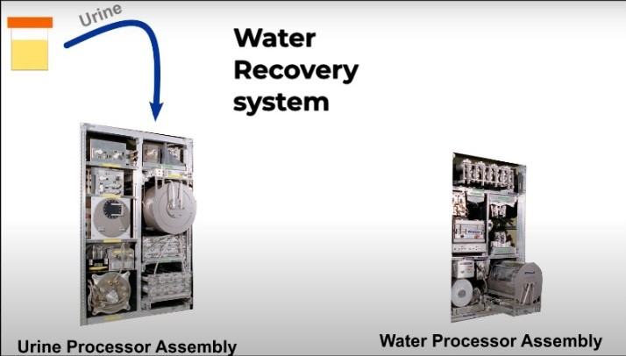

1. Water Cycle in Space Station:

  
•Condensation & Collection:  
Much of the water vapour from respiration, plant transpiration, and evaporation from hygiene like shower and hand-wash in a space colony can be captured. Environmental systems closed within the colony can condense the moisture carried by air back into the water using dehumidification units. Water, like Earth's natural water cycle, can be captured throughout the day to recover all of the water that otherwise evaporates out into the environment.

• Filtration & Sterilization:  
The pure filtration systems remove any impurities or particulates in the water once it has been fetched. These include mechanical filters, activated charcoal filters, and even nanofiltration methods. Then, through the sterilization process, pathogens or bacteria from the water are eradicated by UV exposure, chemical treatments, or ozone. This would ensure that it would be safe for human consumption and other usage.

• Water Reuse:  
The purified recycled water is then injected into the colony's supply. It can then be used for drinking water, irrigation on hydroponic farms, and hygiene. In such a closed-loop system, minimal fresh water should be required and every water that passes through the system is constantly reused thus keeping water demands around the colony sustainable.  
As they artificially recreate the natural water cycle around Earth - evaporation, condensation, and precipitation - they can be considered highly efficient when every drop counts: that is in space.  
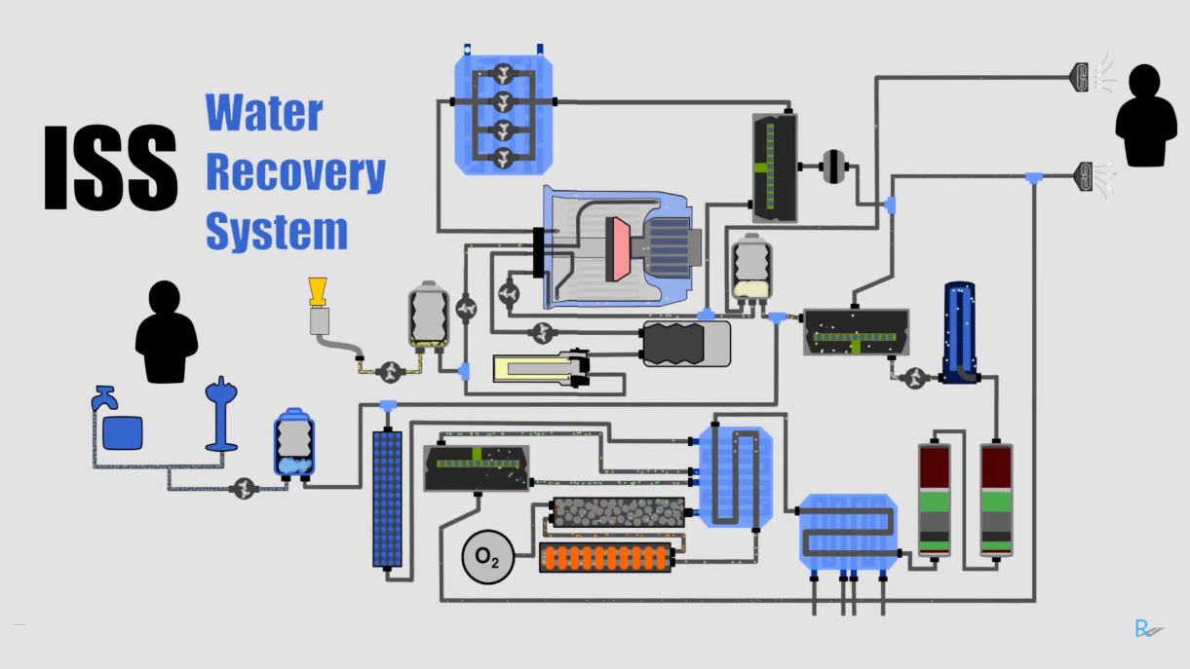

  
2. Urea Crystallization:  
• Urine Recycling:   
Human urine would hold a high percentage of water, which will be recycled. Urine, to be collected inside the space colony, will be treated using the UPA or some of the advanced distillation devices. These machines can extract water from urea and other compounds that may have been used in urine wastes. The separated water is going to be recycled and fed back into the water supply for reuse purposes and the products to be treated as waste are separated, treated or disposed, of accordingly.  
The colony reprocesses urine and recovers water to waste little. Even biowaste itself which leads to a steady supply of water ensures that aspect.  
Real Operation of Water Recycling and Nitrate Removal:  
This will keep the space colony nearly in a closed loop that efficiently cycles water and purifies urea, thereby reducing the resupply of water from Earth and making the colony more autonomous. There is collection and purification of every source of water: whether it is atmospheric or waste, reused so that there's enough life-supporting and agricultural water available for multiple missions of long periods without getting exhausted.

3.3) Water Process Assembly (WPA):

Water Conservation:  
Water will be a costly commodity for the space colony. The WPA will ensure that the recycling of water from urine and other streams is managed efficiently; thus, not much supplementation in terms of resupplying from Earth will be needed. It will make the colony more independent and sustainable.

Cost-Effectiveness:  
It is far too expensive and uneconomical to transport water from Earth in a long-duration mission. On-site treatment of urine and other wastewater helps curb the logistical and monetary costs of keeping a constant water supply at the colony.

  
Reliability  
The WPA was tested successfully in space missions like those of the ISS to prove its sustainability even in extreme environments. Adding it to your colony would mean a proven, reliable system of water recycling for human survival.  
  
Closed-Loop System: It supports the closed-loop life support of the colony: the constant process and utilization of waste products for no-waste maximized resource usage efficiency. That is one essential requirement for the long-term habitation of space.

3.4) Food Production:

Hydroponics in Space Colony: Extent of Explanation  
It is in a space colony, then, that sustainable food-producing systems would provide for long-term survival. Hydroponics is the technique of growing plants in nutrient-enriched water rather than soil. Thus, hydroponics indeed presents an extremely efficient solution for space environments. Check out how hydroponics can be fruitfully applied to your space colony project:  
  
1. Why Hydroponics?

Resource Efficiency  
Water Conservation: Hydroponics uses much smaller volumes of water than conventional soil-based farming. It would be highly beneficial in a space environment as well because water does not come free there. The system recycles, and plants are constantly nourished without wasting these supplies.  
Fast Growth and Increased Productivity  
This, therefore leads to faster growth rates and high productive yields compared to soil as the hydroponically grown plants will uptake all the water and nutrients directly to the roots hence stimulating their optimum growth condition.

Space-Saving  
Hydroponics, for instance, enables what is referred to as vertical farming whereby the crops are grown in layers. This maximises maximum utilization of space only available in a space colony and maximizes productivity per square foot.

  
2. System differences of the Hydroponic System in the Space Colony

Nutrient Film Technique NFT  
Here, a highly thinned stream of nutrient-rich water flows over the roots of plants placed in channels. NFT is ideal for growing leafy greens like lettuce and spinach as they are essentials for a good diet.

Drip systems  
The nutrient solution is dripped directly into the roots of the plants in controlled amounts. It can be extremely effective for fruit-bearing vegetables like tomatoes and peppers that contain many necessary vitamins and minerals.

Deep Water Culture (DWC)   
DWC simply hangs the plant in solution and submerges its root in nutrient water, rich with oxygen. Great for the bigger vegetables, like broccoli and cauliflower, it is packed with much-needed fibre and nutrients.

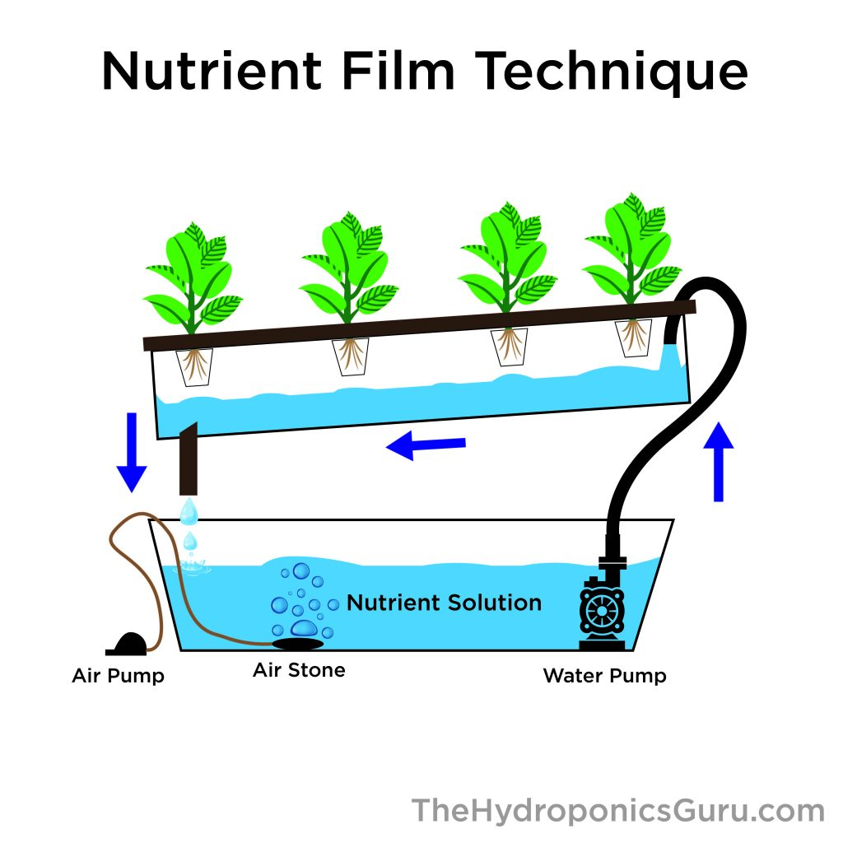  
  
3. Crops Grown in Hydroponics  
Leafy Greens  
Examples: Lettuce, spinach, kale  
These are rich in vitamins, minerals, and antioxidants.  
Herbs  
Examples: Basil, mint, oregano  
Nutrient-dense, flavourful, and adds to the diet.  
Fruits. Vegetables  
Examples: tomatoes, cucumbers, peppers.  
Benefits: Great sources of vitamins and hydration.  
Microgreens  
Example: Radish, Pea Shoot, Alfalfa  
Advantages High yields and nutrient-rich crops.  
4. Hydroponics in Life Support  
Production of Oxygen Plants will remove the carbon dioxide produced by colonists and, through photosynthesis, release oxygen. The outcome would also result in mutualism between humans and plants, which would further benefit to maintain the balance of the life support system.  
  
Nutritional Supply: Hydroponic crops would be an avenue for fresh, nutritious food that is high content of vitamins, minerals, and fibre for the health of colonists inside the confined space environment.

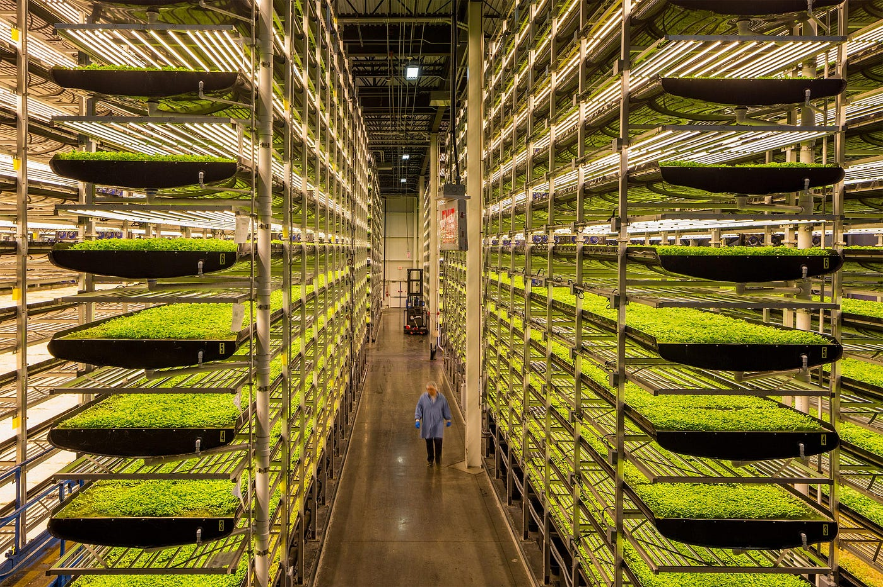

  
5. Colonization of the Space  
Vertical Farming Systems  
Hydroponics would be utilized in vertically stacked systems to maximize the limited colony space and improve the capacity for food production.

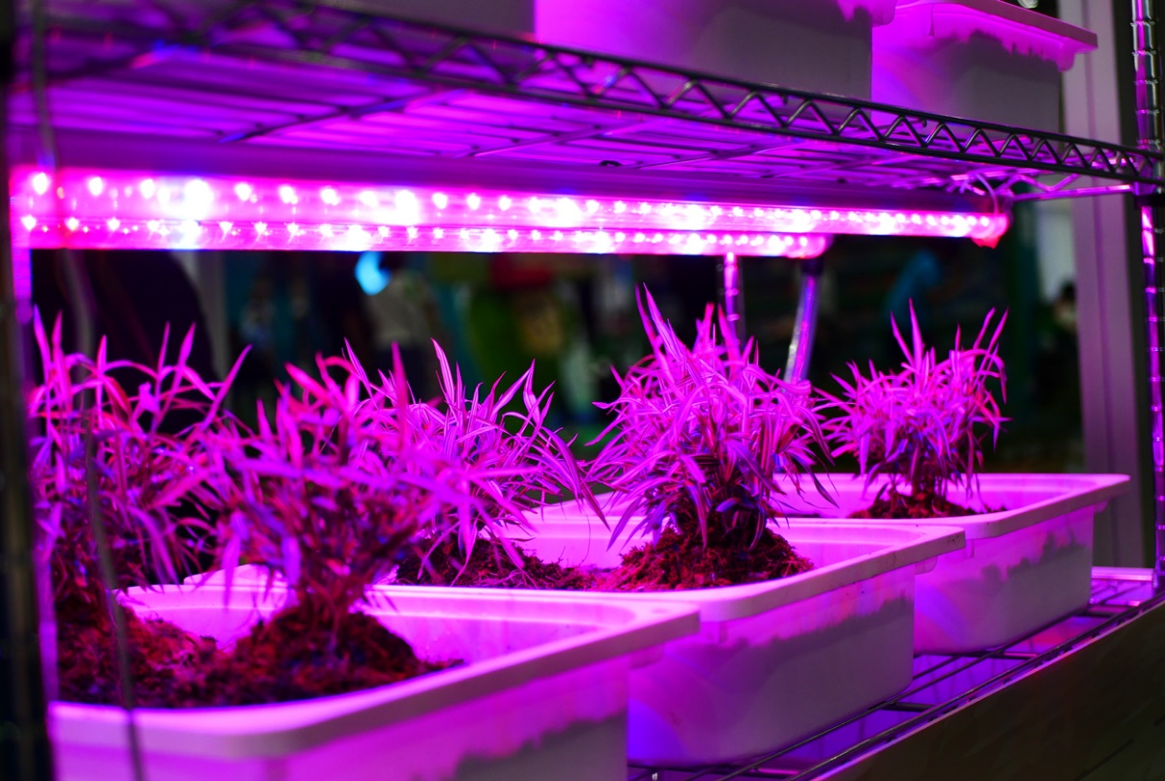Recycling Systems  
Hydroponic water will be constantly recirculated, losing as little as possible. This also means all the redundant water from the colony can be reclaimed by its Water Processing Assembly, so no water goes unused in the system.  
Integration with Life Support  
The oxygen produced by the plants will supplement the life support of the colony, hence constantly providing fresh air. Meanwhile, the carbon dioxide exhaled by the colonists will be consumed by the plants thus sustaining this cycle. Light and Energy Hydroponic systems would use artificial lighting such as LED grow lights or simulation of Earth's sunlight solar light for photosynthesis, etc. There would be solar panels that would provide the energy to be consumed in these lights for the colony.

3.5) Radiation Shielding Using Multilayer Polyethylene

More Safety

Multilayer polyethene would allow much greater overall thickness, greatly increasing the material's capability to absorb cosmic rays as well as charged particles.

Light advantage:



It is also lighter compared to other conventional materials used, such as lead or concrete, because transporting it in space will be less of a challenge and easier to put in place. Every kilogram counts in space.

Cost-Effectiveness:

Polyethylene is considerably cheaper than most of the used radiation shielding materials, hence economically viable for large-scale utilisations in a space colony.

Flexibility in Design:

Multilayer polyethylene can be easily manufactured and shaped, thus allowing creative architectural solutions to be provided that can integrate within the general habitat design.

Corrosion Resistance:

The fact that polyethylene resists corrosion contributes to the overall efficiency of shielding and the long-term safety and sustainability of the space colony.

Nontoxic and safe: **Since polyethylene is not toxic, it has its set of safe applicability in the environment without** posing any harmful health effects to its inhabitants. Simplicity in Installation: The lightweight and flexible nature of multilayer polyethylene makes installation simple, thus the protective structures in the space colony can be done more quickly.

3.6) Energy Supply:  
Solar Panels:  
Design: The solar panels shall be designed specifically to maximize exposure to the sun, probably by employing tracking systems that make the panels shift in such a manner as to fix at an appropriate angle for optimal sunlight absorption all day long.  
Efficiency: Advanced photovoltaic materials are used so that the conversion efficiency is maximized, thus ensuring enough power generation for the needs of the colony.

Storage: Solar power can be stored in high-capacity batteries or other storage systems to have a consistent supply of power when sunlight is not readily available, as during lunar or planetary nights.  
Energy Distribution System:  
  
Smart Grid: A smart grid would allow for an intelligent system for the distribution of energy around the colony. This system would allow monitoring and adjustment of the consumption of energy by all the systems present in the colony, to make optimized use of them and provide energy to all critical systems on need.

Microgrids: The formation of microgrids would allow energy to be better conserved, and hence these independent parts of the colony could operate separately but remain connected to the central power source.  
Backup Power Systems:  
Fuel Cells: Supplemental source of backup power, dependable, because fuel cells can generate electricity using stored hydrogen when solar energy cannot be produced as much.  
  
Waste-to-Energy Systems:  
Waste-to-energy technologies can be further used to increase the sustainability of the above systems. Organic waste can be used through the processes of anaerobic digestion or incineration, to create biogas or electricity and therefore reduce wastes while producing energy.  
Utilization of Thermal Energy  
  
Heat Recovery: Waste heat from most of the colony processes including life support, equipment, etc. can be recovered and used to heat other resources like heating water or cooking food.

3.7) Temperature and Humidity Control in a Colony Space  
A space colony must have environmental control to be able to live comfortably in it. In addition to these aesthetic requirements, temperature and humidity control systems are indispensable to make it inhabitable. Here is how:  
  
Insulation and Thermal Management:  
Multi-layer Insulation: Superior wall and ceiling insulation in place prevents loss of heat. The principle on which multi-layered insulation functions is that of minimizing thermal conductivity and attempting to stabilize the ambient against natural temperature fluctuations.

Use of reflective coatings: Reflective coating applied over the outer surface will help reflect solar radiation during peak hours, consequently reducing heat absorption. It helps to avoid overheating as well as reduces the cooling load on the system.

  
Heating systems:   
Radiant Heating: This system, when installed on walls as well as floors, delivers radiant heating evenly without much energy loss. It is such a system that allows very efficient heating in a comfortable environment.  
Heat Pumps: Heat is drawn out from the outside, or waste heat produced within the colony and distributed to maintain the preferred temperature.  
Cooling systems:  
  
The system can deploy more complex cooling systems such as vapor-compression refrigeration or thermoelectric coolers to reduce hot conditions. Thus, the active-cooling system would be compatible in conjunction with the generated solar power.  
Evaporative Cooling: In this method, evaporative cooling would help cool the environment, using much water to absorb the heat of the surroundings. It is extremely viable in environments wherein humidity conditions are relative and can easily be applied to relative humidity control systems.  
Humidity Control:  
  
Dehumidifiers: Dehumidifiers can be incorporated into these systems to remove excess moisture in the air, maintaining ideal humidity levels. The systems could be designed to recycle and purify atmospheric water supplies into the colony's water. Ventilation Systems. An effective ventilation system is required to ensure proper circulation of air and prevent the build-up of humidity. They can also be designed with air filters that will maintain the quality of air and remove their harmful contaminants.  
  
Environmental monitoring:  
Sensors and Automation: Place environmental sensors throughout the colony to monitor temperature and humidity levels. Use sensed data from these sensors to change heating and cooling outputs automatically to fine-tune the environment. Feedback loops: Feedback loops may be included in the control mechanism so that the response is better to environmental fluctuation, thereby making it stable and comfortable. Thermal Mass Utilization Use of High Thermal Mass Materials Often, materials of high thermal mass are used for regulating fluctuations in temperature. For example, concrete or water can be a thermal reservoir where the surplus heat developed during the day is absorbed and then distributed to the surroundings at night.

3.8)







